**Altered structure-function coupling in the connectome of medication-naïve adults with childhood onset attention-deficit hyperactivity disorder**

Luke J. Hearne1,3*, Hsiang-Yuan Lin2*, Susan Shur-Fen Gau2,3, Luca Cocchi4

1 Center for Molecular and Behavioral Neuroscience, Rutgers University, Newark, New Jersey.

2 Department of Psychiatry, National Taiwan University Hospital, and College of Medicine, Taipei, Taiwan.

3 Graduate Institute of Brain and Mind Sciences, National Taiwan University College of Medicine, Taipei, Taiwan.

4 Clinical Brain Networks Group, QIMR Berghofer Medical Research Institute, Brisbane, Queensland, Australia.

* Shared first authorship

Corresponding author:

Susan Shur-Fen Gau, …

…

Abbreviated title: Brain network structure-function coupling in ADHD

Number of pages:

Figures:

Tables:

Number of words: X (Abstract), X (Introduction), X(Discussion)

**Abstract**

**Introduction:** Adults with ADHD are characterized with altered structural and functional connectivity, respectively. However, the direct relationship between structural and functional brain networks in ADHD has remained uncharted.

**Methods:** To investigate this 78 medication-naive adults with established childhood-onset ADHD without co-occurring psychiatric conditions, and 118 age-, sex-, and intelligence-matched healthy controls underwent assessments of multi-echo resting-state functional and diffusion spectrum imaging. The network-based statistic was used to characterize between-group differences in whole-brain structural connectivity. Hub regions were defined based on structural network organizations.

**Results:** Groups did not differ in global structural network organizations (density and connectivity strengths), as well as whole-brain structural connectivity. Relative to controls, adults with ADHD showed reduced structure-function connectivity coupling in the whole brain connectome, particularly in connections between hub and periphery brain regions, so-called “feeders”. This alteration was mainly driven by structure-function decoupling within the control network, between the control and default-mode, and between the control and sensorimotor systems. Lower structure-function coupling strengths were associated with higher ADHD symptom scores.

**Conclusions:** Overall, as the first study, our results highlight that less constraints placed on the functional connectivity by the underlying structural network organizations may lead to the categorical diagnosis and dimensional symptoms of ADHD. The current study not only suggests the importance of considering the effects of altered structural and functional connectivity in ADHD, but also opens up a new avenue for understanding potential pathophysiology in light of complex interplay between structural and functional network coupling.

**Introduction**

Attention-deficit hyperactivity disorder (ADHD) during adulthood is a neurodevelopmental disorder with clear accounts of inattentive and hyperactive-impulsive symptoms beginning in childhood [(Asherson, Buitelaar, Faraone, & Rohde, 2016)](https://www.zotero.org/google-docs/?GTl02J). Despite the high prevalence, and clear links to functional and mental health problems, the identification of neural biomarkers of adult ADHD is not well-established, with heterogeneous findings. This dearth of knowledge impedes the understanding of mechanisms underpinning remissions, which are greatly needed to inform novel targeted interventions for ADHD [(Sudre, Mangalmurti, & Shaw, 2018)](https://www.zotero.org/google-docs/?NtIwnk).

Emerging neuroimaging work has provided important insights on the altered structural [(Aoki, Cortese, & Castellanos, 2018; L. Chen et al., 2016; van Ewijk, Heslenfeld, Zwiers, Buitelaar, & Oosterlaan, 2012)](https://www.zotero.org/google-docs/?fdTxJc) and functional [(Castellanos & Aoki, 2016)](https://www.zotero.org/google-docs/?0E1IcU) connectivity underpinning ADHD symptoms. Known affected microstructures include the white matter bundles connecting the bilateral cerebral hemispheres, posterior circuits related to the limbic and occipital systems [(L. Chen et al., 2016)](https://www.zotero.org/google-docs/?uVoZ4A), as well as frontal-striatal-cerebellar and frontoparietal pathways [(Rubia, Alegria, & Brinson, 2014; van Ewijk et al., 2012)](https://www.zotero.org/google-docs/?JKnDxP) across the lifespan. Recent work exploring the connectome — modelling the brain as a complex graph to explore topological organization — have supported these regional involvements [(Cao, Shu, Cao, Wang, & He, 2014)](https://www.zotero.org/google-docs/?abtFpj). This research suggests that less-optimized topological organizations of structural networks, in terms of reduced global but increased local efficiency in children with ADHD [(Cao et al., 2014)](https://www.zotero.org/google-docs/?ywbqM3), as well as preserved global but altered local properties in adults with ADHD [(Sidlauskaite, Caeyenberghs, Sonuga-Barke, Roeyers, & Wiersema, 2015)](https://www.zotero.org/google-docs/?McIWNk). Studies of the functional networks related to these white matter structures, specifically the tracts interconnecting the default-mode and frontoparietal networks, and have shown similar findings [(Castellanos & Aoki, 2016; Rubia et al., 2014)](https://www.zotero.org/google-docs/?v6S54Y).

In the domain of functional connectivity, resting-state functional magnetic resonance image (fMRI) studies have highlighted that the diagnosis and symptoms of ADHD are linked to a reduced segregation between the activity of networks supporting external task engagement and the default mode brain network [(Castellanos & Aoki, 2016; Cocchi et al., 2012; H.-Y. Lin et al., 2018)](https://www.zotero.org/google-docs/?Eg4RmU). These results are consistent with studies showing that attention lapses are linked to default mode network activity ‘interfering’ with networks supporting goal directed task engagement and performance [(Weissman, Roberts, Visscher, & Woldorff, 2006)](https://www.zotero.org/google-docs/?bOlf72). More recently, by adopting multivariate methods to link brain activity and behaviour, our work has highlighted that adult ADHD symptoms map onto altered functional interactions between default-mode and control networks [(H.-Y. Lin et al., 2018)](https://www.zotero.org/google-docs/?P1FA5A). Reduced connectivity within the default-mode network, as well as complicated alterations within affective systems, also have often been reported in youths and adults with ADHD [(Castellanos & Aoki, 2016; Rubia et al., 2014)](https://www.zotero.org/google-docs/?YdtcCt).

Despite known distinct contributions of structural and functional networks to ADHD, the direct relationship between structure and function in ADHD has remained uncharted. Specifically, to our knowledge, only two recent studies [(Bos et al., 2017; Ray et al., 2014)](https://www.zotero.org/google-docs/?6eFWVm) combined both modalities of resting-state fMRI and diffusion imaging, but in children with ADHD. Closing this knowledge gap is important because it has been established that the connectome plays a fundamental role in constraining functional dynamics [(Deco, Jirsa, & McIntosh, 2011)](https://www.zotero.org/google-docs/?dm8lEF). A lack of association between structural and functional connectivity may therefore point to core abnormalities in whole-brain neural dynamics. In keeping with this notion, altered structure-function coupling, i.e., associations between neuroimaging indices of structural and functional brain connectivity, has been found in schizophrenia [(Cocchi et al., 2014; Skudlarski et al., 2010; van den Heuvel et al., 2013)](https://www.zotero.org/google-docs/?8PLR0g). Crucially, such dissociations seem to be greater in connections linking hub regions [(van den Heuvel et al., 2013)](https://www.zotero.org/google-docs/?t0IWoy), supporting the general notion that psychiatric conditions are primarily pathologies of brain hubs [(Crossley et al., 2014; de Lange et al., 2018)](https://www.zotero.org/google-docs/?Rub6A4).

Here, we used state-of-the-art multi-echo resting-state fMRI and diffusion spectrum imaging (DSI) to investigate possible changes in whole-brain function-structure coupling in a sample of medication-naïve adults with ADHD [(H.-Y. Lin et al., 2018)](https://www.zotero.org/google-docs/?4umW3y). Based on previous neuroimaging work [(Crossley et al., 2014; van den Heuvel et al., 2013)](https://www.zotero.org/google-docs/?9RJLrG), we hypothesized that greater dissociation between functional and structural connectivity in hubs connections would be observed in ADHD. This structure-function decoupling would be associated with ADHD symptoms. Specifically, we predicted that such alterations will occur in hubs belonging to default-mode and control networks.

**Methods**

*Participants and procedure*

We recruited 80 medication-naïve adults with childhood-onset ADHD aged 18–39 years (mean 26.7 years), who fulfilled full DSM-IV-TR criteria for the current diagnosis of ADHD (i.e., >6 symptoms in either inattention, hyperactivity/impulsivity, or both domains). This, medication-naïve, carefully phenotyped sample allows the unequivocal assessment of structural and functional brain networks in the absence of common confounding variables including developmental delays and cognitive problems. Results from the clinical sample were benchmarked against the findings of 123 age (mean 25.7 years), sex, and IQ-matched healthy controls that did not show any clinically relevant psychopathology.

Participants were assessed at the adult ADHD special clinic of the Department of Psychiatry, National Taiwan University Hospital (NTUH), Taipei, Taiwan from March 2014 to December 2016. The sample has been previously used to assess the multivariate relationship between ADHD symptoms and functional network activity [(H.-Y. Lin et al., 2018)](https://www.zotero.org/google-docs/?PH5cQH). Extensive details regarding the recruitment procedure are described in our previous work [(H.-Y. Lin et al., 2018)](https://www.zotero.org/google-docs/?gHbD3i). Briefly, recruitment occurred via advertisements at hospitals, colleges and online. Potential participants were screened using the Chinese version of the Adult ADHD Self-Report Scale (ASRS) v1.1 [(C.-B. Yeh, Gau, Kessler, & Wu, 2008)](https://www.zotero.org/google-docs/?JqNSuG). Individuals deemed eligible to enter the study were invited for a clinical interview conducted by a board-certified child psychiatrist with extensive experience in ADHD (Author S.S.G.). A diagnosis of ADHD resulting from the clinical interview was confirmed by the Conners’ Adult ADHD Diagnostic Interview [(Conners, Erhardt, & Sparrow, 1999)](https://www.zotero.org/google-docs/?AD9Z4G) and the adult version of the ADHD supplement of the Chinese version of the Kiddie-Schedule for Affective Disorders and Schizophrenia–Epidemiological Version for childhood and current ADHD [(Y.-J. Lin, Yang, & Gau, 2016)](https://www.zotero.org/google-docs/?S7kzDw). Matched healthy controls were recruited using the same procedure adopted for the ADHD group. For both ADHD and controls the following exclusion criteria were adopted: medical illness other than ADHD, substance abuse, past or current use of psychotropic medication, cognitive deficits (<80 full-scale IQ measured by the Wechsler Adult Intellectual Scale-Third Edition [(Tulsky, Saklofske, Wilkins, & Weiss, 2001)](https://www.zotero.org/google-docs/?784lKd)). The study was approved by the Research Ethics Committee of the NTUH (201401024RINC) and registered as a clinical trial (NCT02642068). Written informed consent was obtained for all participants.

*Imaging acquisition*

Brain imaging data were acquired with a Siemens 3 T Tim Trio scanner equipped with a 32-channel head coil located at the NTUH. The imaging protocol included: localizer, resting state fMRI (7 min and 39 seconds), T1-weighted, and DSI. Functional images implicate multi-echo EPI sequence: TR = 2.55 s; flip angle = 90°; matrix size = 64 × 64; in-plane resolution = 3.75 mm; FOV = 240 mm; 31 oblique slices, alternating slice acquisition slice thickness 3.75 mm with 10% gap; iPAT factor = 3; band- width = 1698 Hz/pixel; echo time, TE = 12, 28, 44 and 60 msec). T1 image applied MPRAGE sequence with a TR = 2 s; TE = 2.98 msec; flip angle = 9°; matrix size = 256 × 256; inversion time = 900 msec; voxel size = 1 mm3. DSI used pulsed-gradient spin-echo diffusion echo planar imaging sequence with a twice-refocused balanced echo repetition time/echo time = 9600/130 msec, slice thickness = 2.5 mm, acquisition matrix = 80 × 80, field of view = 200 × 200 mm, in-plane spatial resolution = 2.5 mm × 2.5 mm, 101 diffusion-encoding directions covering a half q-space 3D grid with radial grid size of 3, bmax= 4000 s/mm2 [(Wedeen, Hagmann, Tseng, Reese, & Weisskoff, 2005)](https://www.zotero.org/google-docs/?KJqfqI)

*MRI Preprocessing*

Details regarding the preprocessing of the multi-echo resting-state data are described comprehensively elsewhere [(H.-Y. Lin et al., 2018)](https://www.zotero.org/google-docs/?uXGgOe). In short, the pipeline included: comprehensive data denoising using multi-echo independent components analysis [(ME-ICA v3.0 beta1, Kundu, Inati, Evans, Luh, & Bandettini, 2012; Parkes, Fulcher, Yücel, & Fornito, 2018)](https://www.zotero.org/google-docs/?2LHs5r), coregistration to individual anatomical images, non-linear normalization to MNI space and subsequent filtering (0.01∼0.1 Hz). Micro-head movements were not significantly different between ADHD and controls (*p* = 0.23).

The DSI data first underwent a quality assurance procedure to ensure acceptable in-scanner head motion: Each DSI image of the individual [54 slices × (101 directions DW images + 1 null image) = 5,508 images] was scrutinized by calculating signals in the central square (20 × 20 pixels) of each image. Signal loss was defined as the average signal intensity of an image lower than two standard deviations from the mean of all images (after correcting for its b value) [(Y.-J. Chen et al., 2015)](https://www.zotero.org/google-docs/?1Lf1zB). As jerky head motion induces signal loss in DSI images, these signal dropout counts were considered a proxy estimate for overall levels of in-scanner head motions. Individuals of DSI data with more than 90 images of signal loss, at either baseline or follow-up, were excluded from further analyses [(Y.-J. Chen et al., 2015)](https://www.zotero.org/google-docs/?fGVnvm), resulting in a final sample of 78 adults with ADHD and 118 healthy controls (**Table 1**).

**Table 1. Demographic and clinical features of the participants.**

|  |  |  |  |
| --- | --- | --- | --- |
| **Mean (SD)** | **Control (N=118)** | **ADHD (N=78)** | **Statistics** |
| **Age (18-39 years)** | 25.8 (5.0) | 26.6 (5.5) | *p* = 0.287 |
| **Sex (M/F)** | 76/42 | 54/24 | *p* = 0.484 |
| **Handedness (R/L)** | 113/5 | 64/14 | *p* = 0.001 |
| **FIQ** | 109.8 (9.3)  (range: 89-138) | 107.5 (10.4)  (range: 80-137) | *p* = 0.101 |
| **VIQ** | 108.2 (9.0) | 105.7 (11.2) | *p* = 0.088 |
| **PIQ** | 110.4 (11.4) | 108.3 (16.3) | *p* = 0.289 |
| ***ADHD symptoms*** |  |  |  |
| **Inattentiona** | 6.6 (4.9) | 19.6 (5.0) | *p* < 0.001 |
| **Hyperactivity/Impulsivitya** | 3.2 (4.4) | 13.4 (6.4) | *p* < 0.001 |
| **ASRS-A** | 13.3 (5.2) | 27.0 (4.8) | *p* < 0.001 |
| **ASRS-B** | 9.1 (5.2) | 19.9 (6.3) | *p* < 0.001 |
| **Mean frame-wise displacementb (mm)** | 0.045 (0.021)  (range: 0.014-0.123) | 0.048 (0.024)  (range: 0.017-0.108) | *p* = 0.354 |
| **Signal dropout countsc** | 30.8 (22.4) | 28.8 (21.4) | *p* = 0.536 |

a Measured by the parent-rated Swanson, Nolan, and Pelham, version IV (SNAP-IV) scale.

b Estimated by the Euclidian norm (enorm: square root of the sum of squares of the differences in motion derivatives), computed with AFNI's 1d_tool.py.

c A summary estimate of in-scanner motion levels (see the Methods).

Abbreviation: ADHD=attention-deficit hyperactivity disorder; FIQ=full intelligence quotient; PIQ=performance intelligence quotient; VIQ=verbal intelligence quotient; ASRS=Adult ADHD Self-Report Scale; M=male; F=female; R=right; L=left; SD=standard deviation.

DSI data were reconstructed using the *q*-space diffeomorphic reconstruction (QSDR) approach implemented in DSI Studio ([www.dsi-studio.labsolver.org](http://www.dsi-studio.labsolver.org/)) [(F.-C. Yeh, Wedeen, & Tseng, 2011)](https://www.zotero.org/google-docs/?dTbMYr). QSDR first computed the quantitative anisotropy in each voxel in native space. Then the reconstructed images were warped to a template quantitative anisotropy volume in Montreal Neurological Institute (MNI) space using constrained diffeomorphic mapping. In MNI space, a diffusion sampling length ratio of 1.25 mm with five fiber orientation per voxel and 8-fold orientation distribution function tessellation (642 sampling directions) was used to obtain the spin distribution function, and the output resolution was 2 mm. A deterministic fiber tracking algorithm [(F.-C. Yeh, Verstynen, Wang, Fernández-Miranda, & Tseng, 2013)](https://www.zotero.org/google-docs/?GFOyMM) was performed with extreme turning angle threshold of 60°, step size of 1.0 mm, minimum and maximum length of 10  and 400 mm, respectively. 10,000,000 streamlines were seeded throughout the whole brain and terminated when the local quantitative anisotropy fell below values estimated using Otsu's threshold [(F.-C. Yeh et al., 2013)](https://www.zotero.org/google-docs/?uB4EYM), which gives the optimal separation between background and foreground. Other tracking parameters as specified in DSI Studio were: Smoothing: 0; Seed orientation: all; Seed position: subvoxel; Randomize seeding: off; Direction interpolation: trilinear.

*Functional and structural network construction*

We generated whole-brain structural and functional connectivity matrices for each participant, based on a common and recently validated cortical parcellation [(Schaefer et al., 2018)](https://www.zotero.org/google-docs/?Y7bhDz). Fourteen additional subcortical structures from the Harvard-oxford atlas (<https://fsl.fmrib.ox.ac.uk/fsl/fslwiki/Atlases)> including the thalamus and the striatum were added to the parcellation resulting in 214 total regions (represented as *Schaefer-214* in the following text; **Supplementary Table 1**). For the structural connectome data, the individual’s whole-brain tractography maps were combined with the pre-defined anatomical boundaries based on the parcellation [(Schaefer et al., 2018)](https://www.zotero.org/google-docs/?ou0SAC) to generate a weighted structural network (a 214 × 214 weighted structural connectivity matrix). Each network edge corresponds to the total number of normalized streamlines that interconnect two regions, adjusted for the interregional fiber length. For the resting-state functional data, mean regional time series were extracted for each region within this parcellation [(Schaefer et al., 2018)](https://www.zotero.org/google-docs/?UdD1Mq) and correlated to populate the matrix. The Fisher z-transformation was applied to each correlation coefficient within the matrix.

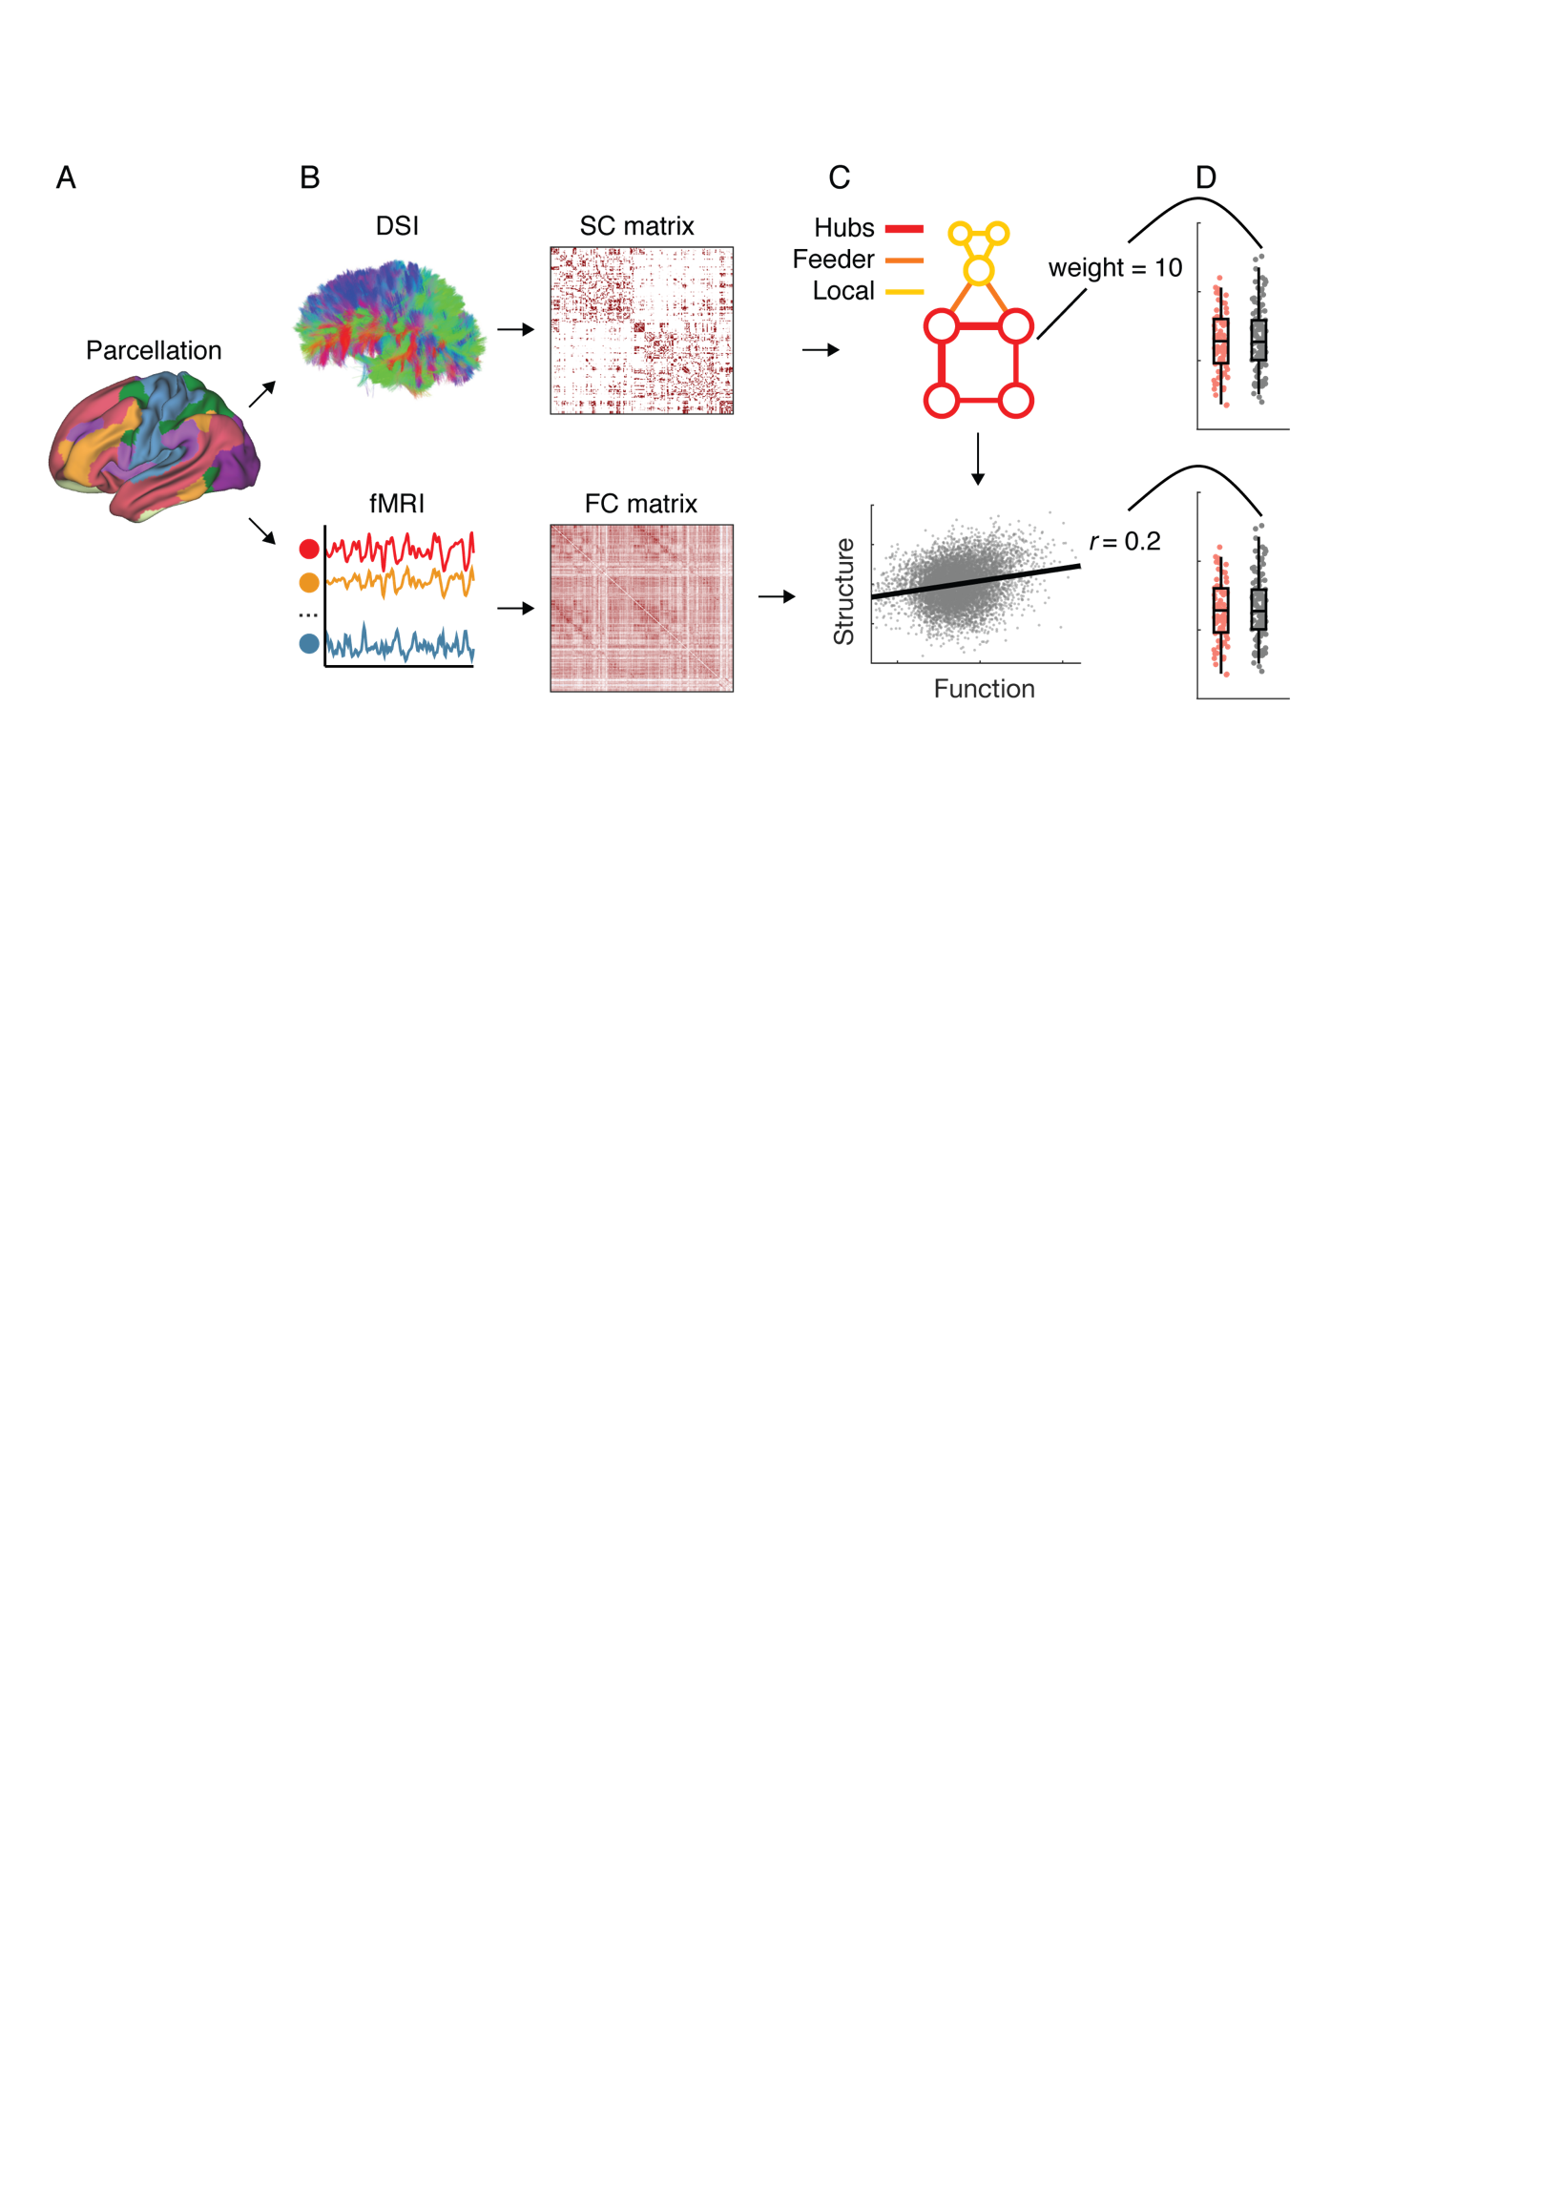

**Figure 1. Conceptual overview of analysis pipeline. A.** Analyses were conducted using a whole brain parcellation including 214 cortical and subcortical regions. **B.** Structural and functional connectivity matrices were derived from diffusion tensor imaging (DSI) and resting-state fMRI data, respectively. In such matrices darker colours indicate higher normalized streamline counts (structural connectivity) and higher fisher-z normalized pearson correlation values (functional connectivity) between every possible pair of brain regions. **C.** The topological organisation of the structural matrices was examined to derive measures of different connection types: hub connections, feeder connections, and local connections. The putative association between structural and functional connectivity was assessed at individual level. **D.** Individual level measures of structural connectivity (top) and structure-function coupling (bottom) were used to build group-level distributions that were analysed using non-parametric statistics and related to behaviour.

*Connection classes: hub, feeder and local connections*

Varying definitions of network hubs exist [(Sporns, Honey, & Kötter, 2007)](https://www.zotero.org/google-docs/?K3hC3l). Here, we identified hub-regions according to aggregate ranking across multiple metrics [(Betzel et al., 2014; Perry et al., 2015)](https://www.zotero.org/google-docs/?1kgR4g). First, for each participant, each node's “hubness” was calculated from its composite average ranking across degree, strength, betweenness and subgraph centrality scores using the brain connectivity toolbox (Rubinov and Sporns, 2010). The top 15% composite scores (N = 32, **Supplementary Table 1**) were used to identify hub-regions within each participant, all other nodes were assigned as *periphery* nodes. Hub *connections* were defined as edges that connected any two hub nodes. Feeder connections linked hub-nodes to periphery nodes, and local connections linked periphery nodes [(van den Heuvel, Kahn, Goñi, & Sporns, 2012; van den Heuvel et al., 2013)](https://www.zotero.org/google-docs/?7iSXZi).

*Structure-function relationships*

Brain network structure-function relationships were conducted in line with previous research with case-control experiment designs [(van den Heuvel et al., 2013)](https://www.zotero.org/google-docs/?Ghcblt). First, non-zero SC values within each individual connectome were isolated and normalized using a rank-based inverse gaussian transformation (Van der Waerden BL, 1952). This vector of structural connectivity values was then correlated with corresponding functional connectivity values (i.e., the same edges) within individual, producing a single Pearson *r* value summarizing the structural-functional connectivity correlation for each participant [(Honey et al., 2009; van den Heuvel et al., 2013)](https://www.zotero.org/google-docs/?Qvh8Qp). These values were then used to populate group distributions (healthy control versus ADHD) to be examined with between-groups statistics. This entire procedure was completed at the whole graph level and within each respective connection class; hubs, feeder and local edges.

To examine the possibility of effects specific to functional networks, this analysis was repeated once more in connections that were specific to control, default-mode and sensory networks. Control networks were defined as fronto-parietal, attention and cingulo-opercular affiliations from the adopted parcellation, while sensory connections included both visual and sensory-motor affiliations. Default-mode connections were as in the original parcellation. Network affiliations were combined to ensure that enough edges were included in each analyses to conduct a robust structure-function correlation (defined here as at least 50 data in each vector). Once structure-function coupling was estimated within each network, the mean *r* values (Control - ADHD) were presented within and between each network as a qualitative analysis.

*Relationship between structure-function coupling and symptoms*

Given the notion that the measures of ADHD symptoms are continuously distributed in the general population [(Coghill & Sonuga-Barke, 2012; Demontis et al., 2018)](https://www.zotero.org/google-docs/?zX3Km5), we implemented the analysis of brain-behavior relationships across the ADHD and control groups leveraging the large total sample size. Inattention and hyperactivity/impulsivity symptoms based on the self-rated ASRS [(C.-B. Yeh et al., 2008)](https://www.zotero.org/google-docs/?HdLpb6) and parent-reported SNAP-IV [(Gau et al., 2008)](https://www.zotero.org/google-docs/?krs7ud) (see **Table 1**) were considered in the analysis. These four symptom items were transformed using a rank-based inverse gaussian, then entered into a principle component analysis to reduce the dimensionality of the data and establish a single reliable measure. The first component, accounting for 80.72% of the variance, was then correlated with structure-function coupling. One participant without behavioural data was excluded from this analysis (N = 195). Pearson’s correlation was used to assess the brain-symptom relationship, given the behavioural data was already transformed to a gaussian distribution.

*Statistical comparisons across groups*

To ensure that structural global network density could not explain between-group differences, summed binary and summed weighted degree were compared between groups. Average connection weight within each *connection class* (hubs, feeder and local) were compared between each group. In addition, the network based statistic [(Zalesky, Fornito, & Bullmore, 2010)](https://www.zotero.org/google-docs/?HN1QS1) was used to explore any possible differences in structural connectivity (not limited to connection classes) between the control and ADHD group (5000 permutations). As ADHD associated alterations of functional connectivity using the network based statistic in the same sample have been reported elsewhere [(H.-Y. Lin et al., 2018)](https://www.zotero.org/google-docs/?3kWOnb), herein we intentionally did not implement this analysis for the functional networks.

Non-parametric Wilcoxon rank sum tests were used to identify possible differences in the function-structure association between control and ADHD groups. Bonferroni corrections were applied to reported statistics. Statistical significance was declared when the estimated alpha error, bonferroni corrected for multiple comparison, was less than 5%. To quantify effect size z-values are reported.

*Reliability and stability of results*

A number of tests were conducted to establish the reliability of our findings. In addition to the adapted *Schaefer-214* template, results were reproduced using two other templates of different resolution and nature [(Fan et al., 2016; Shen, Tokoglu, Papademetris, & Constable, 2013)](https://www.zotero.org/google-docs/?yydBU5). This step resulted in a 213 × 213 network matrix (excluding two inferior temporal regions with inadequate coverage, and 53 cerebellar nodes; *Shen-213*) [(Shen, Tokoglu, Papademetris, & Constable, 2013)](https://www.zotero.org/google-docs/?l0lDC0), and a 244 × 244 network matrix (excluding two inferior temporal regions; *Brainnetome-244*) [(Fan et al., 2016)](https://www.zotero.org/google-docs/?InjWN8), respectively, for the supplementary analyses (**Supplementary Table 2**). Different levels of hub threshold (12.5% and 17.5%) were also tested (**Supplementary Table 3**). Repeating the structure-function coupling analysis with no structural connectivity data transform had no effect on the results. The group difference of structure-function coupling in feeders was tested for stability by sequentially deleting a random subject from both groups and reperforming the analysis. This process was repeated 1000 times to generate 95% confidence intervals indicating at what loss of *N* the results would not be replicated (**Supplemental Figure ?**). In addition to the correlating the PCA components with structure-function coupling, associations of brain measures with each individual symptom measure were also tested (**Supplementary Table 5**). All statistics were performed in MATLAB (Mathworks) and the code is available via github (https://github.com/ljhearne/ADHDSCFC).

**Results**

*Group comparison with structural connectivity*

We began by testing for possible differences in structural connectivity between healthy controls and medication-naive ADHD. Group-averaged adjacency matrices are shown in **Figure 2A**. Non-parametric t-tests revealed no difference in weighted (*p* = .89, *z* = 0.13), or unweighted summed degree across groups (*p* = .24, *z* = -1.19, **Figure 2B**). Likewise, whole-brain network-based statistic comparing ADHD and healthy control groups revealed no significant differences.

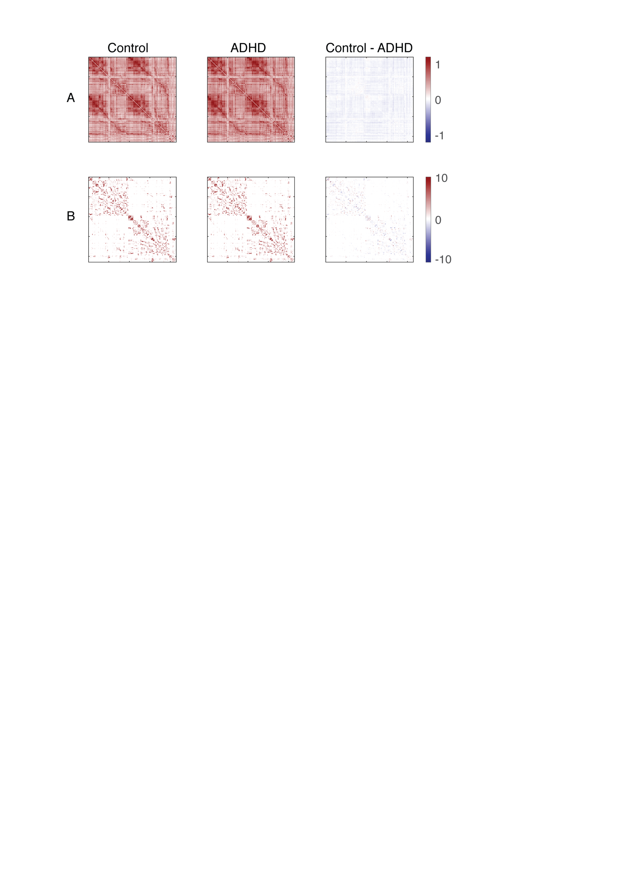

**Figure 2.** *Whole-brain structural and functional networks of healthy controls and medication naive adults with ADHD.* **A.** Group-averaged functional connectivity matrices for controls and ADHD. The third, right-most matrix represents the difference between the groups (Control – ADHD). **B.** As above, withgroup-averaged structural connectivity matrices. None of our analyses indicated group differences in structural connectivity alone.

Next we sought to investigate potential differences in *classes* of structural connections, namely hubs, feeders, and local connections (van den Heuval et al., 2012). Non-parametric *t*-tests revealed no significant difference between ADHD and healthy control groups when comparing mean connection strength within hub (*p* = .86, *z* = -0.17), feeder (*p* = .77, *z* = -0.29), or local connections (*p* = .23, *z* = 1.21). Collectively, these results demonstrated comprehensive non-significant differences between ADHD and control groups in the structural connectome (**Figure 3**).

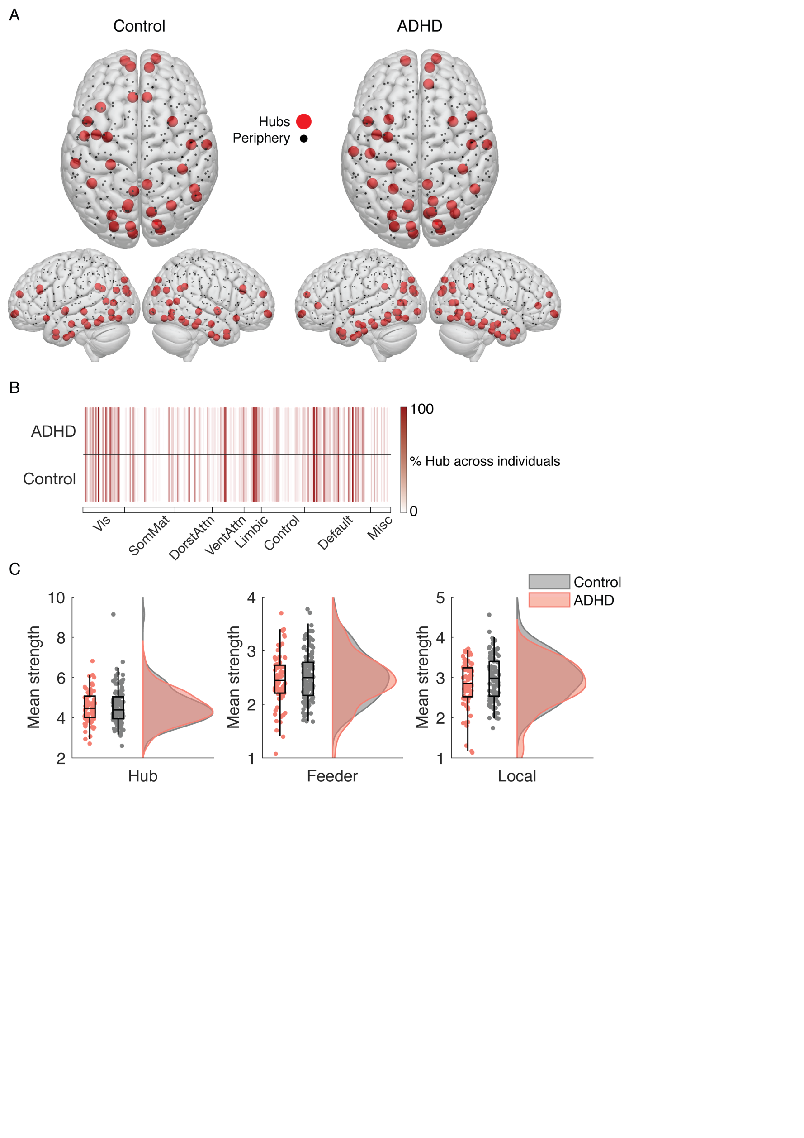

**Figure 3.** *Structural Hub topology in ADHD and healthy controls.* **A.** Brain rendering of group average hub (red) and periphery (black) nodes. In line with all other structural analyses, they are similar. **B.** Individual-level representation of hub nodes, where darker lines indicate more consistency within each group (i.e., dark red represents every individual had a hub node within the ADHD or Control group). **C.** Distributions of the average strength of hub, feeder and local connections visualized with ‘raincloud’ plots (Allen et al., 2018). Healthy controls are shown in grey and the ADHD group is shown in orange. There were no significant differences found.

*Structural-functional connectivity coupling*

In the next section of analyses, we considered the correlation between structural connections and functional connectivity edges, assigning each individual a single Pearson *r* value, hereafter referred to as SC-FC coupling. When considering the all edges within the graph, results indicated a significant difference in SC-FC coupling (*p* = .01, *z* = 2.51, **Figure 4A**). As above, we then assessed the contribution of each connection class type (hub, feeder or local). Results suggested ADHD had a lower function-structure association in feeder connections (*p bonferonni corrected for three comparisons* = .005, *z* = 3.10) but not in hub (*pbonf ~*= 1, *z* = 0.55) or local (*pbonf* = .33 *z* = 1.60) connections.

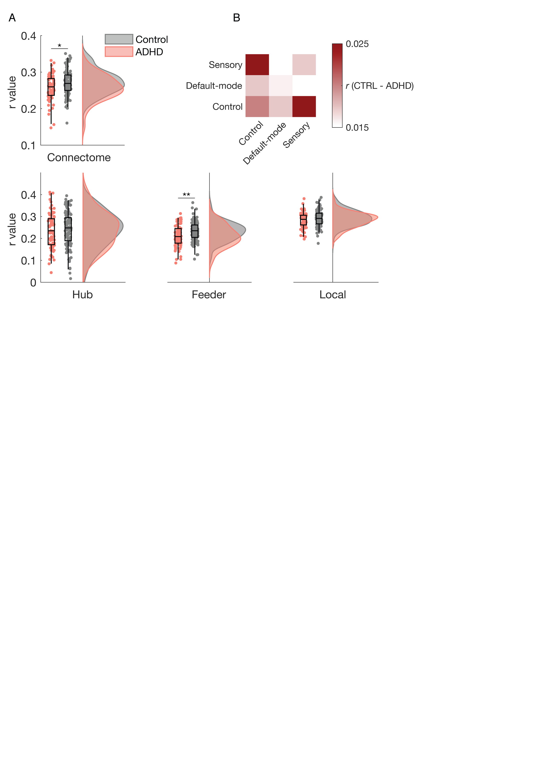

**Figure 4.** *Structure-function relationships in ADHD and healthy control groups.* **A.** Distributions of *r* values across the whole connectome (top) and the three connection classes (bottom). Healthy controls are shown in grey and the ADHD group is shown in orange. Significant differences were observed in the whole connectome but were likely driven by feeder connections. **B.** Mean difference in SC-FC coupling when constrained to feeder connections within and between control, default-mode and sensory functional networks. The largest differences (shown in darker red colours) were found within and between control network connections. * < .05, ** < .01 corrected for multiple comparisons.

*Network-specificity of Feeder structural-functional connectivity coupling*

We next tested the specificity of structure-function coupling in regard to well-characterized functional brain networks. To do so, we isolated feeder connections that belonged to control (an agglomeration of frontoparietal, salience, dorsal attention networks), default-mode, or sensory (merging somatomotor and visual) networks, and measured the structure-function coupling within and between these groups of connections. To avoid statistical “double-dipping” [(Kriegeskorte, Simmons, Bellgowan, & Baker, 2009)](https://www.zotero.org/google-docs/?UHNDjM), we present the subtraction of coupling within the Control and ADHD groups (**Figure 4B**). The largest differences were located within control networks and between the control network and default-mode or sensory networks.

*Relationship with symptoms*

Our final analysis investigated the putative relationship between the above structure-function coupling and ADHD symptoms. To reduce the dimensionality of the behavioural measures we conducted a PCA revealing a single component accounting for 80.71% of the variance which all four behaviours loaded onto (see **Supplementary Table 4**). We found that individual component loadings correlated significantly with feeder structure-function coupling (*p* = .0004, *r* = -0.25, see **Figure 5**), suggesting lower coupling was associated with higher scores on the composite of ADHD symptoms.

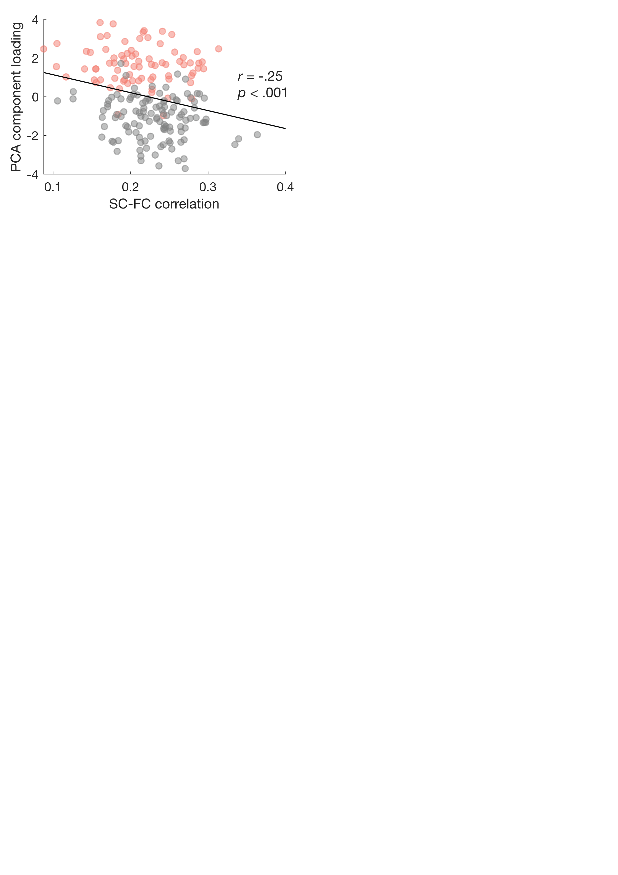

**Figure 5.** *Correlation between symptom and structural-functional connectivity (SC-FC) coupling in feeder connections.*

*Robustness analyses*

We replicated the results using two other, independent brain parcellations (*Shen-213* and *Brainnetome-244,* **see Supplementary Table 2**). Interestingly, using these two auxiliary parcellations (*Shen-213* and *Brainnetome-244*), adults with ADHD further exhibited weaker structure-function coupling in hub connections, despite a smaller effect size compared to that in the feeder comparison. ADHD-associated reduction in structure-function coupling in the whole connectome and feeder connections was also observed when different thresholds (12.5% and 17.5%) were used to define hubness based on the main parcellation (*Schaeffer-214*) (**Supplementary Table 3**).

The negative correlation between structural-functional coupling and ADHD symptoms were also replicated in the ancillary analysis using the individual scores of self- and parent-rated symptoms (**Supplementary Table 5**). The brain-symptom relationships obtained using *Shen-213* and *Brainnetome-244* atlases also showed negative associations (**Supplementary Table 2**).

**Discussion**

The present study provides the first direct evidence of alterations in structure-function coupling in the connectome of medication-naive adults with childhood-onset ADHD, using multi-echo resting-state fMRI and DSI deterministic tractography. We observed reduced structure-function coupling in ADHD specifically in connections between brain hub and periphery nodes. This alteration was mainly driven by structure-function decoupling within the control network, between the control and default-mode, and between the control and sensory systems. Moreover, lower structure-function coupling was associated with higher ADHD symptom scores.

Emerging evidence has suggested that underlying structural networks place strong constraints on functional connectivity and activity in the brain [(Deco et al., 2011; Deco & Kringelbach, 2014; Hermundstad et al., 2013; Honey et al., 2009)](https://www.zotero.org/google-docs/?OtHx4X). Decoupling of the link between functional and structural brain connectivity has been shown to potentially contribute to the pathological state of major psychiatric disorders, especially schizophrenia [(Cocchi et al., 2014; Skudlarski et al., 2010; van den Heuvel et al., 2013)](https://www.zotero.org/google-docs/?cxVwqy). As we predicted, ADHD is also characterized with reduced structural-functional correspondence in the connectome, which were mainly driven by structure-function decoupling in feeder connections. Despite inconsistency among different brain parcellations (two similarly significant results out of three atlases), structure-function correspondence in hub connections also appeared to be reduced in ADHD. Structure-function decoupling in hub and feeder connections in ADHD support the theory that the hubs and their connections (spanning between hubs, as well as between hubs and peripheral brain regions) form a central bridge function for neural communication and integration [(van den Heuvel et al., 2012; van den Heuvel & Sporns, 2013)](https://www.zotero.org/google-docs/?zdfobM). Disruptions in central connections would result in disproportionately large effects leading to brain dysfunction [(Crossley et al., 2014; de Lange et al., 2018)](https://www.zotero.org/google-docs/?CiBdhf). Hubs and feeder connections in particular usually consist of relatively long anatomical routes allowing efficient communication between distant regions comprising different functional modules [(Perry et al., 2015; van den Heuvel et al., 2012)](https://www.zotero.org/google-docs/?YTRKxk). Accordingly, our findings in hub and feeder connections echo the prior work showing that ADHD favors short-range anatomical covariance [(Bethlehem, Romero-Garcia, Mak, Bullmore, & Baron-Cohen, 2017)](https://www.zotero.org/google-docs/?ZTVq5w).

Notably, we identified that feeder connections linking within control systems, between control and default-mode, as well as between control and sensory networks, predominantly contributed to reduced structure-function coupling in ADHD. Such findings are consistent with previous resting-state fMRI literature which highlights the potential involvement of these systems and their interactions in the pathophysiology of ADHD [(Cary et al., 2017; Castellanos & Aoki, 2016; Cocchi et al., 2012; H.-Y. Lin et al., 2018; H.-Y. Lin, Tseng, Lai, Matsuo, & Gau, 2015)](https://www.zotero.org/google-docs/?fkqbVl). Moreover, prior work also suggests that dynamics between the these systems are critical in facilitating the normal functions of selective [(Regev et al., 2018)](https://www.zotero.org/google-docs/?gAevJN) and sustained [(Weissman et al., 2006)](https://www.zotero.org/google-docs/?7uldkm) attention. We also observed a correlation with behaviour such that reduced structure-function coupling was associated with higher ADHD symptomology. Taken together, we speculate that the reduced structure–function coupling may be indicative of more unrestrained dynamic brain function from the underlying structural scaffolding, which results in suboptimal modulation of interplay between the control, default-mode, and sensorimotor networks in adults with ADHD. This inefficiency may lead to the observed cognitive and behavioral deficits such as inattention.

The finding of the dissociation between structural and functional connectivity in ADHD is indirectly in line with previous work using similar methodology (diffusion imaging and resting-state fMRI). Bos and colleagues [(Bos et al., 2017)](https://www.zotero.org/google-docs/?fk7k0C) showed that changes in functional connectivity were not accompanied by changes in the underlying white matter structures in ADHD children. Similarly, we also did not observe significant between-group differences in structural connectivity. Some explanations may account for this inconsistency with other prior studies [(Aoki et al., 2018; L. Chen et al., 2016)](https://www.zotero.org/google-docs/?qDSURa). The methods applied herein (the basic topological properties of connectome and network-based statistic) are distinct from previously used tract-based statistics. ADHD-associated alterations in white matter microstructures may be of non-specific properties [(Liston, Malter Cohen, Teslovich, Levenson, & Casey, 2011)](https://www.zotero.org/google-docs/?t0WSfS), and their effect sizes may be too small to survive multiple comparison testing. In addition, the present null finding may reflect our emphasis on comparable levels of head motion between ADHD and controls, as emerging evidence has indicated that in-scanner motion tends to produce spurious group differences [(Yendiki, Koldewyn, Kakunoori, Kanwisher, & Fischl, 2014)](https://www.zotero.org/google-docs/?PTZYpt). Accordingly, a recent meta-analysis highlighted that studies with no differences in head motion between groups tended to report null findings in diffusion imaging measures associated with ADHD [(Aoki et al., 2018, 2017)](https://www.zotero.org/google-docs/?QTSXzf). Our distinct cohort with medication-naive adults having established childhood-onset ADHD in the absence of co-occurring psychiatric conditions may also partly contribute to this negative finding, as psychostimulant exposure [(de Luis-García et al., 2015)](https://www.zotero.org/google-docs/?CB0atI) and comorbidity [(Adisetiyo et al., 2014)](https://www.zotero.org/google-docs/?nVSs2v) have been reported to affect diffusion findings in ADHD. Our findings highlight that future investigations should comprehensively consider confounding factors contributing to heterogeneity in the ADHD literature. Simultaneously, despite no between-group differences in structural connectivity alone, our exploration of structure-function coupling shed new light on the role of structural networks and their correspondence with the functional brain connectivity in ADHD.

Our findings should be interpreted considering some other limitations and caveats. First, while the high resolution (101 diffusion directions), advanced acquisition and reconstruction methods of DSI allow for better capacity to address the crossing fibers issue [(Le Bihan & Johansen-Berg, 2012)](https://www.zotero.org/google-docs/?4xA58Q), deterministic fiber tractography is limited by the ambiguous reliability of the reconstructed tracts [(Maier-Hein et al., 2017)](https://www.zotero.org/google-docs/?TP6La5). The development of novel tractography methods and using probabilistic algorithms - which takes direction-uncertainty into account but is hitherto unavailable for DSI - would complement the current findings in future. Second, we implemented multi-echo acquisitions to better denoise resting-state fMRI data involving a trade-off between levels of spatial and temporal resolution [(Kundu et al., 2012)](https://www.zotero.org/google-docs/?husg7t). Third, although the sex distribution was not different between the ADHD and control groups, and the sex ratio of the current ADHD sample was typical (Asherson *et al.*, 2016), most participants are male. Hence, the present findings may not generalize to female predominant cohorts. Fourth, our participants exhibited higher levels of inattention than hyperactivity-impulsivity problems. Although this clinical profile reflects the typical presentation of adult ADHD, it limits the inference of relations between structure-function dissociation and inhibitory and cognitive control. Lastly, the objective of this study was based on the presumption that the anatomical brain architectures mediates functional interactions between different regions, which support cognitive function. However, with the accumulating data from human patients in the absence of corpus callosum [(Hearne et al., 2018; Tyszka, Kennedy, Adolphs, & Paul, 2011)](https://www.zotero.org/google-docs/?FkrmsB), a caveat should be borne in mind that the structure-function relationship in the brain transcends one-to-one correspondence [(Mišić et al., 2016)](https://www.zotero.org/google-docs/?m1w1GM). Such mappings reflect complex interactions between large-scale functional and structural brain organizations, which await disambiguation from future computational, theoretical, and multimodal experimental studies.

In sum, as the first investigation of this kind in the ADHD literature, we report structural-functional connectivity decoupling in the connectome of ADHD, despite negative between-group differences in structural networks. This reduced structure-function correspondence in ADHD was mainly driven by connections linking hubs and peripheral regions spanning the large-scale brain systems critical in the pathophysiology of ADHD. These findings highlight that less constraints placed on the functional connectivity by the underlying structural network organizations may lead to the categorical diagnosis and dimensional symptoms of ADHD. Together, the current study not only suggests the importance of considering the respectful effects of altered structural and functional connectivity, but also opens up a new avenue for understanding reciprocal linkages between structural and functional brain networks in ADHD.

**References**

[Adisetiyo, V., Tabesh, A., Di Martino, A., Falangola, M. F., Castellanos, F. X., Jensen, J. H., & Helpern, J. A. (2014). Attention-deficit/hyperactivity disorder without comorbidity is associated with distinct atypical patterns of cerebral microstructural development. *Human Brain Mapping*, *35*(5), 2148–2162. https://doi.org/10.1002/hbm.22317](https://www.zotero.org/google-docs/?h0HfhC)

[Aoki, Y., Cortese, S., & Castellanos, F. X. (2018). Research Review: Diffusion tensor imaging studies of attention-deficit/hyperactivity disorder: meta-analyses and reflections on head motion. *Journal of Child Psychology and Psychiatry, and Allied Disciplines*, *59*(3), 193–202. https://doi.org/10.1111/jcpp.12778](https://www.zotero.org/google-docs/?h0HfhC)

[Aoki, Y., Yoncheva, Y. N., Chen, B., Nath, T., Sharp, D., Lazar, M., … Di Martino, A. (2017). Association of White Matter Structure With Autism Spectrum Disorder and Attention-Deficit/Hyperactivity Disorder. *JAMA Psychiatry*, *74*(11), 1120–1128. https://doi.org/10.1001/jamapsychiatry.2017.2573](https://www.zotero.org/google-docs/?h0HfhC)

[Asherson, P., Buitelaar, J., Faraone, S. V., & Rohde, L. A. (2016). Adult attention-deficit hyperactivity disorder: key conceptual issues. *The Lancet. Psychiatry*, *3*(6), 568–578. https://doi.org/10.1016/S2215-0366(16)30032-3](https://www.zotero.org/google-docs/?h0HfhC)

[Bethlehem, R. a. I., Romero-Garcia, R., Mak, E., Bullmore, E. T., & Baron-Cohen, S. (2017). Structural Covariance Networks in Children with Autism or ADHD. *Cerebral Cortex (New York, N.Y.: 1991)*, *27*(8), 4267–4276. https://doi.org/10.1093/cercor/bhx135](https://www.zotero.org/google-docs/?h0HfhC)

[Betzel, R. F., Byrge, L., He, Y., Goñi, J., Zuo, X.-N., & Sporns, O. (2014). Changes in structural and functional connectivity among resting-state networks across the human lifespan. *NeuroImage*, *102 Pt 2*, 345–357. https://doi.org/10.1016/j.neuroimage.2014.07.067](https://www.zotero.org/google-docs/?h0HfhC)

[Bos, D. J., Oranje, B., Achterberg, M., Vlaskamp, C., Ambrosino, S., de Reus, M. A., … Durston, S. (2017). Structural and functional connectivity in children and adolescents with and without attention deficit/hyperactivity disorder. *Journal of Child Psychology and Psychiatry, and Allied Disciplines*, *58*(7), 810–818. https://doi.org/10.1111/jcpp.12712](https://www.zotero.org/google-docs/?h0HfhC)

[Cao, M., Shu, N., Cao, Q., Wang, Y., & He, Y. (2014). Imaging functional and structural brain connectomics in attention-deficit/hyperactivity disorder. *Molecular Neurobiology*, *50*(3), 1111–1123. https://doi.org/10.1007/s12035-014-8685-x](https://www.zotero.org/google-docs/?h0HfhC)

[Cary, R. P., Ray, S., Grayson, D. S., Painter, J., Carpenter, S., Maron, L., … Fair, D. A. (2017). Network Structure among Brain Systems in Adult ADHD is Uniquely Modified by Stimulant Administration. *Cerebral Cortex (New York, N.Y.: 1991)*, *27*(8), 3970–3979. https://doi.org/10.1093/cercor/bhw209](https://www.zotero.org/google-docs/?h0HfhC)

[Castellanos, F. X., & Aoki, Y. (2016). Intrinsic Functional Connectivity in Attention-Deficit/Hyperactivity Disorder: A Science in Development. *Biological Psychiatry : Cognitive Neuroscience and Neuroimaging*, *1*(3), 253–261. https://doi.org/10.1016/j.bpsc.2016.03.004](https://www.zotero.org/google-docs/?h0HfhC)

[Chen, L., Hu, X., Ouyang, L., He, N., Liao, Y., Liu, Q., … Gong, Q. (2016). A systematic review and meta-analysis of tract-based spatial statistics studies regarding attention-deficit/hyperactivity disorder. *Neuroscience and Biobehavioral Reviews*, *68*, 838–847. https://doi.org/10.1016/j.neubiorev.2016.07.022](https://www.zotero.org/google-docs/?h0HfhC)

[Chen, Y.-J., Lo, Y.-C., Hsu, Y.-C., Fan, C.-C., Hwang, T.-J., Liu, C.-M., … Tseng, W.-Y. I. (2015). Automatic whole brain tract-based analysis using predefined tracts in a diffusion spectrum imaging template and an accurate registration strategy. *Human Brain Mapping*, *36*(9), 3441–3458. https://doi.org/10.1002/hbm.22854](https://www.zotero.org/google-docs/?h0HfhC)

[Cocchi, L., Bramati, I. E., Zalesky, A., Furukawa, E., Fontenelle, L. F., Moll, J., … Mattos, P. (2012). Altered functional brain connectivity in a non-clinical sample of young adults with attention-deficit/hyperactivity disorder. *The Journal of Neuroscience: The Official Journal of the Society for Neuroscience*, *32*(49), 17753–17761. https://doi.org/10.1523/JNEUROSCI.3272-12.2012](https://www.zotero.org/google-docs/?h0HfhC)

[Cocchi, L., Harding, I. H., Lord, A., Pantelis, C., Yucel, M., & Zalesky, A. (2014). Disruption of structure-function coupling in the schizophrenia connectome. *NeuroImage. Clinical*, *4*, 779–787. https://doi.org/10.1016/j.nicl.2014.05.004](https://www.zotero.org/google-docs/?h0HfhC)

[Coghill, D., & Sonuga-Barke, E. J. S. (2012). Annual research review: categories versus dimensions in the classification and conceptualisation of child and adolescent mental disorders--implications of recent empirical study. *Journal of Child Psychology and Psychiatry, and Allied Disciplines*, *53*(5), 469–489. https://doi.org/10.1111/j.1469-7610.2011.02511.x](https://www.zotero.org/google-docs/?h0HfhC)

[Conners, C. K., Erhardt, D., & Sparrow, E. (1999). *CAARS: Conner’s Adult ADHD Rating Scales*. Multi-Health Systems Incorporated (MHS).](https://www.zotero.org/google-docs/?h0HfhC)

[Crossley, N. A., Mechelli, A., Scott, J., Carletti, F., Fox, P. T., McGuire, P., & Bullmore, E. T. (2014). The hubs of the human connectome are generally implicated in the anatomy of brain disorders. *Brain: A Journal of Neurology*, *137*(Pt 8), 2382–2395. https://doi.org/10.1093/brain/awu132](https://www.zotero.org/google-docs/?h0HfhC)

[de Lange, S. C., Scholtens, L. H., van den Berg, L. H., Boks, M. P., Bozzali, M., Cahn, W., … van den Heuvel, M. P. (2018). Shared vulnerability for connectome alterations across psychiatric and neurological brain disorders. *BioRxiv*. https://doi.org/10.1101/360586](https://www.zotero.org/google-docs/?h0HfhC)

[de Luis-García, R., Cabús-Piñol, G., Imaz-Roncero, C., Argibay-Quiñones, D., Barrio-Arranz, G., Aja-Fernández, S., & Alberola-López, C. (2015). Attention deficit/hyperactivity disorder and medication with stimulants in young children: a DTI study. *Progress in Neuro-Psychopharmacology & Biological Psychiatry*, *57*, 176–184. https://doi.org/10.1016/j.pnpbp.2014.10.014](https://www.zotero.org/google-docs/?h0HfhC)

[Deco, G., Jirsa, V. K., & McIntosh, A. R. (2011). Emerging concepts for the dynamical organization of resting-state activity in the brain. *Nature Reviews. Neuroscience*, *12*(1), 43–56. https://doi.org/10.1038/nrn2961](https://www.zotero.org/google-docs/?h0HfhC)

[Deco, G., & Kringelbach, M. L. (2014). Great expectations: using whole-brain computational connectomics for understanding neuropsychiatric disorders. *Neuron*, *84*(5), 892–905. https://doi.org/10.1016/j.neuron.2014.08.034](https://www.zotero.org/google-docs/?h0HfhC)

[Demontis, D., Walters, R. K., Martin, J., Mattheisen, M., Als, T. D., Agerbo, E., … Neale, B. M. (2018). Discovery of the first genome-wide significant risk loci for attention deficit/hyperactivity disorder. *Nature Genetics*, 1. https://doi.org/10.1038/s41588-018-0269-7](https://www.zotero.org/google-docs/?h0HfhC)

[Fan, L., Li, H., Zhuo, J., Zhang, Y., Wang, J., Chen, L., … Jiang, T. (2016). The Human Brainnetome Atlas: A New Brain Atlas Based on Connectional Architecture. *Cerebral Cortex (New York, N.Y.: 1991)*, *26*(8), 3508–3526. https://doi.org/10.1093/cercor/bhw157](https://www.zotero.org/google-docs/?h0HfhC)

[Gau, S. S.-F., Shang, C.-Y., Liu, S.-K., Lin, C.-H., Swanson, J. M., Liu, Y.-C., & Tu, C.-L. (2008). Psychometric properties of the Chinese version of the Swanson, Nolan, and Pelham, version IV scale - parent form. *International Journal of Methods in Psychiatric Research*, *17*(1), 35–44. https://doi.org/10.1002/mpr.237](https://www.zotero.org/google-docs/?h0HfhC)

[Hearne, L. J., Dean, R. J., Robinson, G. A., Richards, L. J., Mattingley, J. B., & Cocchi, L. (2018). Increased cognitive complexity reveals abnormal brain network activity in individuals with corpus callosum dysgenesis. *NeuroImage. Clinical*. https://doi.org/10.1016/j.nicl.2018.11.005](https://www.zotero.org/google-docs/?h0HfhC)

[Hermundstad, A. M., Bassett, D. S., Brown, K. S., Aminoff, E. M., Clewett, D., Freeman, S., … Carlson, J. M. (2013). Structural foundations of resting-state and task-based functional connectivity in the human brain. *Proceedings of the National Academy of Sciences of the United States of America*, *110*(15), 6169–6174. https://doi.org/10.1073/pnas.1219562110](https://www.zotero.org/google-docs/?h0HfhC)

[Honey, C. J., Sporns, O., Cammoun, L., Gigandet, X., Thiran, J. P., Meuli, R., & Hagmann, P. (2009). Predicting human resting-state functional connectivity from structural connectivity. *Proceedings of the National Academy of Sciences of the United States of America*, *106*(6), 2035–2040. https://doi.org/10.1073/pnas.0811168106](https://www.zotero.org/google-docs/?h0HfhC)

[Kriegeskorte, N., Simmons, W. K., Bellgowan, P. S. F., & Baker, C. I. (2009). Circular analysis in systems neuroscience: the dangers of double dipping. *Nature Neuroscience*, *12*(5), 535–540. https://doi.org/10.1038/nn.2303](https://www.zotero.org/google-docs/?h0HfhC)

[Kundu, P., Inati, S. J., Evans, J. W., Luh, W.-M., & Bandettini, P. A. (2012). Differentiating BOLD and Non-BOLD Signals in fMRI Time Series Using Multi-Echo EPI. *Neuroimage*, *60*(3), 1759–1770. https://doi.org/10.1016/j.neuroimage.2011.12.028](https://www.zotero.org/google-docs/?h0HfhC)

[Le Bihan, D., & Johansen-Berg, H. (2012). Diffusion MRI at 25: exploring brain tissue structure and function. *NeuroImage*, *61*(2), 324–341. https://doi.org/10.1016/j.neuroimage.2011.11.006](https://www.zotero.org/google-docs/?h0HfhC)

[Lin, H.-Y., Cocchi, L., Zalesky, A., Lv, J., Perry, A., Tseng, W.-Y. I., … Gau, S. S.-F. (2018). Brain-behavior patterns define a dimensional biotype in medication-naïve adults with attention-deficit hyperactivity disorder. *Psychological Medicine*, *48*(14), 2399–2408. https://doi.org/10.1017/S0033291718000028](https://www.zotero.org/google-docs/?h0HfhC)

[Lin, H.-Y., Tseng, W.-Y. I., Lai, M.-C., Matsuo, K., & Gau, S. S.-F. (2015). Altered resting-state frontoparietal control network in children with attention-deficit/hyperactivity disorder. *Journal of the International Neuropsychological Society: JINS*, *21*(4), 271–284. https://doi.org/10.1017/S135561771500020X](https://www.zotero.org/google-docs/?h0HfhC)

[Lin, Y.-J., Yang, L.-K., & Gau, S. S.-F. (2016). Psychiatric comorbidities of adults with early- and late-onset attention-deficit/hyperactivity disorder. *Australian & New Zealand Journal of Psychiatry*, *50*(6), 548–556. https://doi.org/10.1177/0004867415609423](https://www.zotero.org/google-docs/?h0HfhC)

[Liston, C., Malter Cohen, M., Teslovich, T., Levenson, D., & Casey, B. J. (2011). Atypical prefrontal connectivity in attention-deficit/hyperactivity disorder: pathway to disease or pathological end point? *Biological Psychiatry*, *69*(12), 1168–1177. https://doi.org/10.1016/j.biopsych.2011.03.022](https://www.zotero.org/google-docs/?h0HfhC)

[Maier-Hein, K. H., Neher, P. F., Houde, J.-C., Côté, M.-A., Garyfallidis, E., Zhong, J., … Descoteaux, M. (2017). The challenge of mapping the human connectome based on diffusion tractography. *Nature Communications*, *8*(1), 1349. https://doi.org/10.1038/s41467-017-01285-x](https://www.zotero.org/google-docs/?h0HfhC)

[Mišić, B., Betzel, R. F., de Reus, M. A., van den Heuvel, M. P., Berman, M. G., McIntosh, A. R., & Sporns, O. (2016). Network-Level Structure-Function Relationships in Human Neocortex. *Cerebral Cortex (New York, N.Y.: 1991)*, *26*(7), 3285–3296. https://doi.org/10.1093/cercor/bhw089](https://www.zotero.org/google-docs/?h0HfhC)

[Parkes, L., Fulcher, B., Yücel, M., & Fornito, A. (2018). An evaluation of the efficacy, reliability, and sensitivity of motion correction strategies for resting-state functional MRI. *NeuroImage*, *171*, 415–436. https://doi.org/10.1016/j.neuroimage.2017.12.073](https://www.zotero.org/google-docs/?h0HfhC)

[Perry, A., Wen, W., Lord, A., Thalamuthu, A., Roberts, G., Mitchell, P. B., … Breakspear, M. (2015). The organisation of the elderly connectome. *NeuroImage*, *114*, 414–426. https://doi.org/10.1016/j.neuroimage.2015.04.009](https://www.zotero.org/google-docs/?h0HfhC)

[Ray, S., Miller, M., Karalunas, S., Robertson, C., Grayson, D. S., Cary, R. P., … Fair, D. A. (2014). Structural and functional connectivity of the human brain in autism spectrum disorders and attention-deficit/hyperactivity disorder: A rich club-organization study. *Human Brain Mapping*, *35*(12), 6032–6048. https://doi.org/10.1002/hbm.22603](https://www.zotero.org/google-docs/?h0HfhC)

[Regev, M., Simony, E., Lee, K., Tan, K. M., Chen, J., & Hasson, U. (2018). Propagation of Information Along the Cortical Hierarchy as a Function of Attention While Reading and Listening to Stories. *Cerebral Cortex (New York, N.Y.: 1991)*. https://doi.org/10.1093/cercor/bhy282](https://www.zotero.org/google-docs/?h0HfhC)

[Rubia, K., Alegria, A., & Brinson, H. (2014). Imaging the ADHD brain: disorder-specificity, medication effects and clinical translation. *Expert Review of Neurotherapeutics*, *14*(5), 519–538. https://doi.org/10.1586/14737175.2014.907526](https://www.zotero.org/google-docs/?h0HfhC)

[Schaefer, A., Kong, R., Gordon, E. M., Laumann, T. O., Zuo, X.-N., Holmes, A. J., … Yeo, B. T. T. (2018). Local-Global Parcellation of the Human Cerebral Cortex from Intrinsic Functional Connectivity MRI. *Cerebral Cortex*, *28*(9), 3095–3114. https://doi.org/10.1093/cercor/bhx179](https://www.zotero.org/google-docs/?h0HfhC)

[Shen, X., Tokoglu, F., Papademetris, X., & Constable, R. T. (2013). Groupwise whole-brain parcellation from resting-state fMRI data for network node identification. *NeuroImage*, *82*, 403–415. https://doi.org/10.1016/j.neuroimage.2013.05.081](https://www.zotero.org/google-docs/?h0HfhC)

[Sidlauskaite, J., Caeyenberghs, K., Sonuga-Barke, E., Roeyers, H., & Wiersema, J. R. (2015). Whole-brain structural topology in adult attention-deficit/hyperactivity disorder: Preserved global - disturbed local network organization. *NeuroImage. Clinical*, *9*, 506–512. https://doi.org/10.1016/j.nicl.2015.10.001](https://www.zotero.org/google-docs/?h0HfhC)

[Skudlarski, P., Jagannathan, K., Anderson, K., Stevens, M. C., Calhoun, V. D., Skudlarska, B. A., & Pearlson, G. (2010). Brain connectivity is not only lower but different in schizophrenia: a combined anatomical and functional approach. *Biological Psychiatry*, *68*(1), 61–69. https://doi.org/10.1016/j.biopsych.2010.03.035](https://www.zotero.org/google-docs/?h0HfhC)

[Sporns, O., Honey, C. J., & Kötter, R. (2007). Identification and classification of hubs in brain networks. *PloS One*, *2*(10), e1049. https://doi.org/10.1371/journal.pone.0001049](https://www.zotero.org/google-docs/?h0HfhC)

[Sudre, G., Mangalmurti, A., & Shaw, P. (2018). Growing out of attention deficit hyperactivity disorder: Insights from the “remitted” brain. *Neuroscience and Biobehavioral Reviews*, *94*, 198–209. https://doi.org/10.1016/j.neubiorev.2018.08.010](https://www.zotero.org/google-docs/?h0HfhC)

[Tulsky, D. S., Saklofske, D. H., Wilkins, C., & Weiss, L. G. (2001). Development of a general ability index for the Wechsler Adult Intelligence Scale--Third Edition. *Psychological Assessment*, *13*(4), 566–571.](https://www.zotero.org/google-docs/?h0HfhC)

[Tyszka, J. M., Kennedy, D. P., Adolphs, R., & Paul, L. K. (2011). Intact bilateral resting-state networks in the absence of the corpus callosum. *The Journal of Neuroscience: The Official Journal of the Society for Neuroscience*, *31*(42), 15154–15162. https://doi.org/10.1523/JNEUROSCI.1453-11.2011](https://www.zotero.org/google-docs/?h0HfhC)

[van den Heuvel, M. P., Kahn, R. S., Goñi, J., & Sporns, O. (2012). High-cost, high-capacity backbone for global brain communication. *Proceedings of the National Academy of Sciences of the United States of America*, *109*(28), 11372–11377. https://doi.org/10.1073/pnas.1203593109](https://www.zotero.org/google-docs/?h0HfhC)

[van den Heuvel, M. P., & Sporns, O. (2013). Network hubs in the human brain. *Trends in Cognitive Sciences*, *17*(12), 683–696. https://doi.org/10.1016/j.tics.2013.09.012](https://www.zotero.org/google-docs/?h0HfhC)

[van den Heuvel, M. P., Sporns, O., Collin, G., Scheewe, T., Mandl, R. C. W., Cahn, W., … Kahn, R. S. (2013). Abnormal rich club organization and functional brain dynamics in schizophrenia. *JAMA Psychiatry*, *70*(8), 783–792. https://doi.org/10.1001/jamapsychiatry.2013.1328](https://www.zotero.org/google-docs/?h0HfhC)

[van Ewijk, H., Heslenfeld, D. J., Zwiers, M. P., Buitelaar, J. K., & Oosterlaan, J. (2012). Diffusion tensor imaging in attention deficit/hyperactivity disorder: a systematic review and meta-analysis. *Neuroscience and Biobehavioral Reviews*, *36*(4), 1093–1106. https://doi.org/10.1016/j.neubiorev.2012.01.003](https://www.zotero.org/google-docs/?h0HfhC)

[Wedeen, V. J., Hagmann, P., Tseng, W.-Y. I., Reese, T. G., & Weisskoff, R. M. (2005). Mapping complex tissue architecture with diffusion spectrum magnetic resonance imaging. *Magnetic Resonance in Medicine*, *54*(6), 1377–1386. https://doi.org/10.1002/mrm.20642](https://www.zotero.org/google-docs/?h0HfhC)

[Weissman, D. H., Roberts, K. C., Visscher, K. M., & Woldorff, M. G. (2006). The neural bases of momentary lapses in attention. *Nature Neuroscience*, *9*(7), 971–978. https://doi.org/10.1038/nn1727](https://www.zotero.org/google-docs/?h0HfhC)

[Yeh, C.-B., Gau, S. S.-F., Kessler, R. C., & Wu, Y.-Y. (2008). Psychometric properties of the Chinese version of the adult ADHD Self-report Scale. *International Journal of Methods in Psychiatric Research*, *17*(1), 45–54. https://doi.org/10.1002/mpr.241](https://www.zotero.org/google-docs/?h0HfhC)

[Yeh, F.-C., Verstynen, T. D., Wang, Y., Fernández-Miranda, J. C., & Tseng, W.-Y. I. (2013). Deterministic diffusion fiber tracking improved by quantitative anisotropy. *PloS One*, *8*(11), e80713. https://doi.org/10.1371/journal.pone.0080713](https://www.zotero.org/google-docs/?h0HfhC)

[Yeh, F.-C., Wedeen, V. J., & Tseng, W.-Y. I. (2011). Estimation of fiber orientation and spin density distribution by diffusion deconvolution. *NeuroImage*, *55*(3), 1054–1062. https://doi.org/10.1016/j.neuroimage.2010.11.087](https://www.zotero.org/google-docs/?h0HfhC)

[Yendiki, A., Koldewyn, K., Kakunoori, S., Kanwisher, N., & Fischl, B. (2014). Spurious group differences due to head motion in a diffusion MRI study. *NeuroImage*, *88*, 79–90. https://doi.org/10.1016/j.neuroimage.2013.11.027](https://www.zotero.org/google-docs/?h0HfhC)

[Zalesky, A., Fornito, A., & Bullmore, E. T. (2010). Network-based statistic: identifying differences in brain networks. *NeuroImage*, *53*(4), 1197–1207. https://doi.org/10.1016/j.neuroimage.2010.06.041](https://www.zotero.org/google-docs/?h0HfhC)